Money Creation

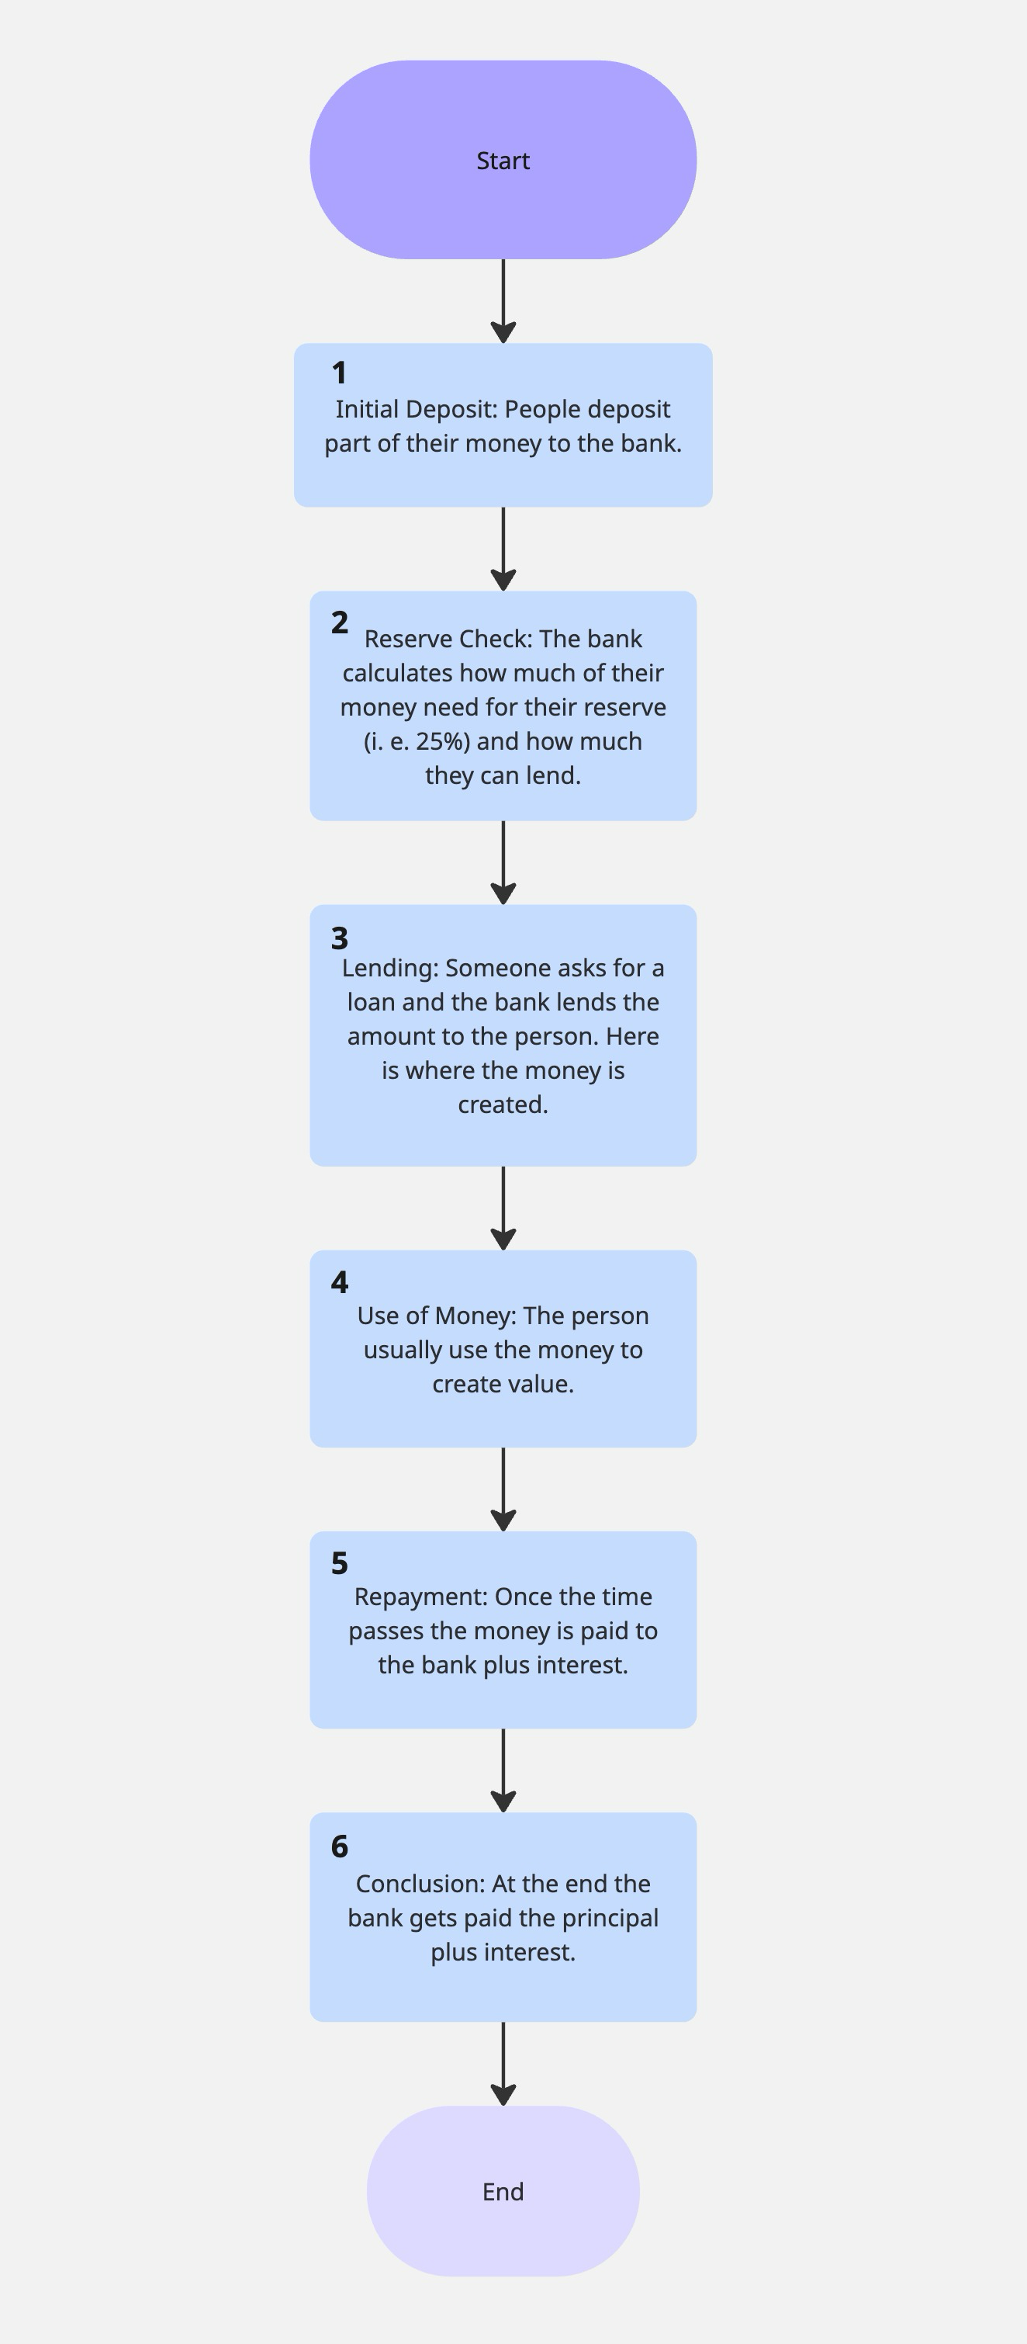

Step 1: Customers make deposits to the bank, which allows them to create their reserve. These deposits become liabilities on the bank's balance sheet.
Step 2: The bank must have a reserve to meet regulations and be able to cover withdrawals. This is fundamental in order for the fractional reserve banking system to work. For example, it can be 25%, which means that it can lend 75% of the money they have.
Step 3: People will ask for a loan, and once the bank approves it, new money is created. A key concept for the system is that money is created when it moves. Now the person has money that can be spent in the economy. The person is credited with a deposit they didn't make, which reflects both an asset (loan receivable) and a liability (deposit) for the bank.
Step 4: The money borrowed is spent into the economy, whether investing in a business or consuming a product or service, the economy is moved. Usually, this money ends up as a deposit in another bank who is able to lend it in the future, creating a money multiplier effect.
Step 5: After a given period of time, the borrower pays back the principal plus the interest. This marks the end of the lending process, and the loan and deposit created disappear from the bank's balance sheet. The interest is the profit the bank makes for assuming the risk of lending the money.
Step 6: Through this cycle, the banking system creates money supply expansion beyond the initial base money deposit. Each bank individually receives back its principal plus interest, but the system as a whole has multiplied the original deposit through successive rounds of lending. This creates an important concept that is the money multiplier effect, which means how much credit a deposit can create. For the 25% reserve example, a $100 initial deposit can create $400.
Video Example: In the video, each person deposited $1,000 out of the $10,000 each one had. With a 25% reserve requirement, the bank can lend $7,500. Someone asks for $7,500 so they can produce their watermelons. The borrower pays someone the $7,500 so they can increase their production and sell it in the future. After a given period of time, the person that borrowed the $7,500 pays the bank back $9,000. After the lending process, an initial economy of $100,000 ends up worth $110,000.

References:

Wendover Productions. (2022, september 7). Money’s mostly digital, so why is moving it so hard? [Vídeo]. YouTube. https://www.youtube.com/watch?v=8xzINLykprA

Juneja, H. (2025, april 3). Multiplier Effect: How fractional reserve banking creates money ? Management Study Guide. https://www.managementstudyguide.com/how-fractional-reserve-banking-creates-money.htm

Fmva, T. V. (2024, december 2). Fractional Banking. Corporate Finance Institute. https://corporatefinanceinstitute.com/resources/economics/fractional-banking/

Complexity of Moving Money

Nowadays moving money seems really simple, you just pay with your card or transfer money with your phone to someone else. While it is true that it seems simple as a user, it requires a very complex network and systems that make this possible, also including a lot of intermediaries that make sure that everything works fine and that we keep our trust in the system. But this was not always true; throughout history moving money has always been an issue and a very complex problem to solve.

Before the Civil War, in the US there were countless different paper monies issued by different banks. A bill from a bank in New York may not be valid or worth the same in a bank from Chicago. This made it really difficult to move money and make sure it was reliable, and also came with a lot of costs because of the uncertainty of moving it.

The National Currency Acts of the 1860s fundamentally changed this landscape. They helped solve the problem through standardization with the help of central banks connecting with some smaller banks across the country. This allowed a check from a local bank to be settled at a larger bank in a big city without the need for moving gold.

This is a foundation of how money moves today, by adjusting accounting relationships between the banks involved in the settling of the check. This created the first system of banking interconnectivity, making it more efficient.

This solved the problem of moving money for a while, but it led to something very unexpected: suffering from success. At the national level, banks needed to process 69 million checks daily through very thorough manual labor, looking at the checks and double-checking the accounting books.

The solution for this problem came from an alliance of Stanford, Bank of America and IBM; this was the creation of ERMA. It introduced standardized check sizes, account numbers, and magnetic ink. This helped do a faster job than humans as well as being way more accurate.

Still, this was not the end of all problems, because the physical traveling of paper was still required to cash and use checks, creating clear bottlenecks in the process. This led to the appearance of the Automated Clearing House (ACH) Network. It revolutionized the industry by enabling direct deposits, automatic payments, and ATM transactions electronically; this was the first glimpse of modern payment systems. Today, the ACH Network moves over $50 trillion across 23 billion transfers annually.

While ACH efficiently moves money domestically, international transfers presented unique challenges, like different currencies, time zones, technologies and methods of processing payments. SWIFT (Society for Worldwide Interbank Financial Telecommunications), established in the 1970s, addressed this by providing 11,000 member banks with a secure network and standardized messaging format for payment orders.

Like most current networks and methods, SWIFT does not move money across countries; it just created a standardized way to give instructions to banks in different countries. This keeps the principle of moving money through accounting adjustments. What it does is somewhat simple: when a transfer occurs, it just gives the instruction to the receiving bank to take money from the sender and convert it to the local currency.

As smart and efficient as this process may appear, it does have an important issue: high costs. SWIFT charges its member banks a fee per message in order to maintain their network and make sure that it is safe; consumers pay a fee of around $40 for an international transfer.

In the current digital era, one of the most common payment mechanisms is using debit or credit cards, making it the dominant payment infrastructure globally. At the center of this are Visa and Mastercard, which are the biggest players in the industry, helping users feel that paying is really simple, which is not the case.

When a consumer pays with Visa or Mastercard, the process involves the merchant, the acquiring bank, the card network, the issuing bank, and multiple processors. Authorization happens in seconds, but settlement occurs later. Each participant takes a fee, commonly resulting in merchant costs between 1.5% and 3% per transaction.

The most common participant structure in these transactions is the following:

1. Card Issuers: Banks that provide cards to consumers and manage accounts
2. Card Networks: Visa, Mastercard, American Express, and Discover set standards and route transaction data
3. Acquiring Banks: Institutions that receive money on behalf of merchants
4. Payment Processors: Companies facilitating the technical infrastructure
5. Merchants: Businesses accepting cards for payment

These fees aren't arbitrary, they fund the infrastructure that makes instant, secure, global payments possible. Interchange rates vary based on card type, merchant category, transaction security level, and whether the card is physically present.

Despite technological advances, moving money remains complex and costly. The main reason is that the accounting must be perfect. If a bank erroneously transfers $1,000 without debiting the sender, money appears from nowhere. When banks create money incorrectly, it undermines the entire system: money breaks, trust breaks, and the system breaks.

This explains why expensive middlemen persist despite technological advances. Banks process transactions through SWIFT, ACH, and card networks because these institutions protect what might be called "simulated physicality."

Proposed solutions to these issues are the fintechs, such as PayPal, Wise, etc. When someone in the US sends $1,000 to Australia, Wise receives money into its American account and instructs its Australian account to send the equivalent amount to the recipient. The same result occurs with far less complexity and cost.

The peer-to-peer (P2P) payment revolution took different approaches to solving similar problems. PayPal created a digital wallet system allowing online payments without sharing financial information with merchants.

Another proposal is blockchain technology, which promises to enable peer-to-peer value transfer without trusted intermediaries through distributed ledger systems. Yet cryptocurrencies haven't displaced traditional payment infrastructure because they face their own challenges.

In conclusion, moving money has always been a complex issue, even today with all of the technological advances. Current networks, processes, and infrastructure remain complex and expensive, which is something necessary in order to maintain trust in the current financial system, where most money is digital and the use of physical money is declining.

Will the solutions proposed by fintechs and blockchain technology be the future? That is a question that only time will tell, but something is sure: the way money moves today will change in the future, because that has always been a constant, finding problems and then fixing them with innovative and creative ideas, which has always helped us improve our way to use money on a daily basis.

References:

Wendover Productions. (2022, september 7). Money’s mostly digital, so why is moving it so hard? [Vídeo]. YouTube. https://www.youtube.com/watch?v=8xzINLykprA

PaymentGenes. (n. d.). https://www.paymentgenes.com/payments-what-the-faq/the-essential-role-of-visa-and-mastercard-in-card-transactions

ByteByteGo | How VISA Works When Swiping a Credit Card. (n. d.). ByteByteGo. https://bytebytego.com/guides/how-does-visa-work-when-we-swipe-a-credit-card-at-a-merchants-shop/

Britannica. Credit card interchange fees: What they are and how they work. (n. d.). https://www.britannica.com/money/credit-card-interchange-fees

Perco, A. (2025, november 4). How PayPal makes money: The fintech giant losing margin to keep its throne. Revenue Memo. https://www.revenuememo.com/p/how-does-paypal-make-money

